**REPUBLIC OF TÜRKİYE**

**MINISTRY OF INTERIOR**

**Turkish Coast Guard Command**

**CURRENT OPERATIONS**

**10 April 2024**

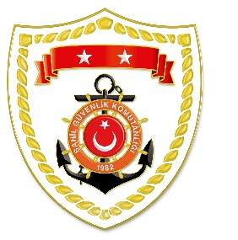

**CG Aegean Sea Regional Command**

|  |  |  |  |  |  |  |
| --- | --- | --- | --- | --- | --- | --- |
| **NU** | **DATE** | **LOCATION/PLACE AND TIME** | **IRREGULAR MIGRATION ASSET** | **TOTAL NUMBER OF APPREHENDED FACILITATORS/**  **SUSPECT** | **TOTAL NUMBER OF RESCUED PEOPLE** | **NATIONALITY OF RESCUED/APPREHENDED MIGRANTS/ PEOPLE ON THE BASIS OF DECLARATION** |
| 1 | 10 April 2024 | Off the Coast of MUĞLA/Bodrum  06.45 | Lastik Bot | - | 29 | 12 Congo, 6 Ivory Coast, 5 Egypt,  5 Sudan, 1 Angola (9 of them children) |
| 2 | 10 April 2024 | Off the Coast of AYDIN/Kuşadası  10.18 | 2 Life Boats | - | 42 | 41 Afghanistan, 1 Iran (19 of them children) |

*Shared data include the records kept during incidents of irregular migration by water. General statistical data are available at goc.gov.tr/duzensiz-goc-istatistikler.